1. PROJECT TITLE:
RFQN: Residual fusion Q net for big data classification using map reduce framework
2. HARDWARE REQUIREMENTS
OS-Windows 10
RAM-8GB
ROM-More than 100 GB
GPU-Yes
CPU-1.7 GHz

3. SOFTWARE REQUIREMENTS
Software name(Python): Version: 3.9.11
(Download link: https://www.python.org/downloads/release/python-3911/)
Click -> Windows installer (64-bit).

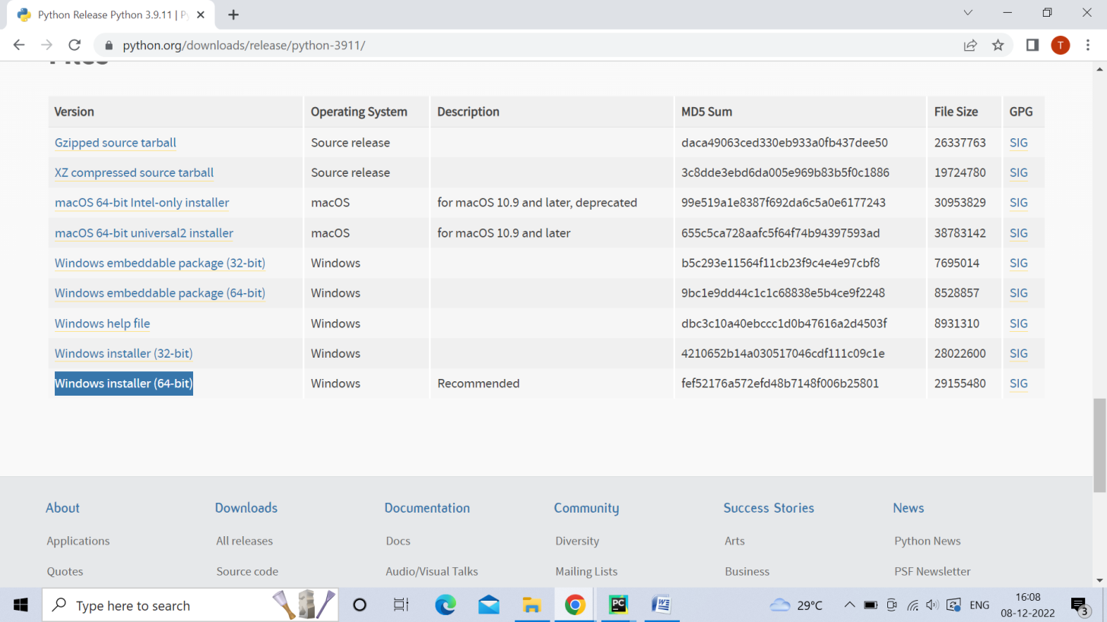

Software name: PyCharm: Version: 2020.3.3
(Download link: https://www.jetbrains.com/pycharm/download/other.html)
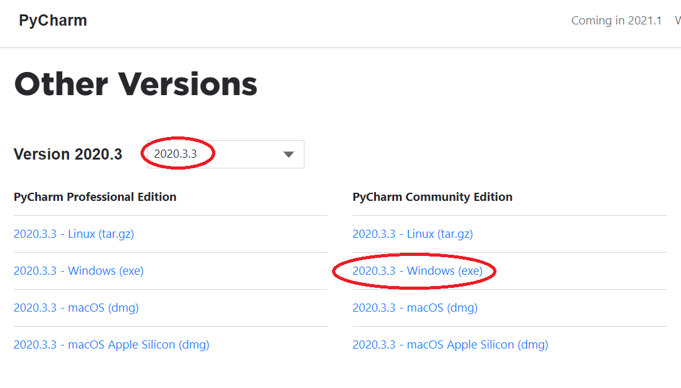
(For installation procedure, please refer the doc “steps to install python.doc”)

4. HOW TO RUN
Step 1: Loading the project in PYCHARM
- Open PyCharm
- Go to File, select Open browse the project from your drive and select it. So that the project will get loaded into the PyCharm.
- For the first time, PyCharm will take some time to load the settings.
- Please wait if any process is loading on the bottom of the screen.
- Check the Project Interpreter (File -> Settings -> Project: final code -> Project Interpreter).
If this location “(C:\Users\---\AppData\Local\Programs\Python\Python39\python.exe) is not presented, then add this ‘python.exe’ from the installed location.
- In PyCharm Terminal (bottom left), type the comment “pip install -r requirements.txt”
Step 2: Run the program and getting the results
- From 'current project folder' window in PyCharm, Open ‘146203bk2-> Main -> GUI.py’ and click run button
- In GUI window
  - Select the dataset ['Adult' or 'Credit_Approval']
  - Select training data (%) or K-value and enter the values (eg: 50)
  - Click START, after some time the result will be displayed
[Expected Execution time expected: 5-10 minutes]
Step 3: Generate the graphs plotted in the paper
- From 'current project folder' window in PyCharm, open ‘Result_graphs.py’, and click run button.

5. IMPORTANT PYTHON FILE AND DESCRIPTION:
GUI.py: User Interface to select the dataset, code starts here
Run.py: Main code starts here
MapReducer.py: Mapper phase: (pre-processing (yeo-jhonson transformation) slave: feature fusion using deep NN and Kulczynski s ; -> data augmentation , master: classification
Proposed/DQN.py.py
Result_graphs.py: displays graphs included in the paper.

